# Everything you need to know about Volumes

Solids of revolution is a cool way to integrate ‘simple’ 3D shapes who have a good relation to circles. For an idea of this, think of the torus

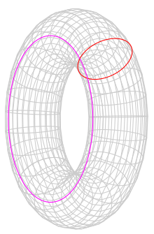

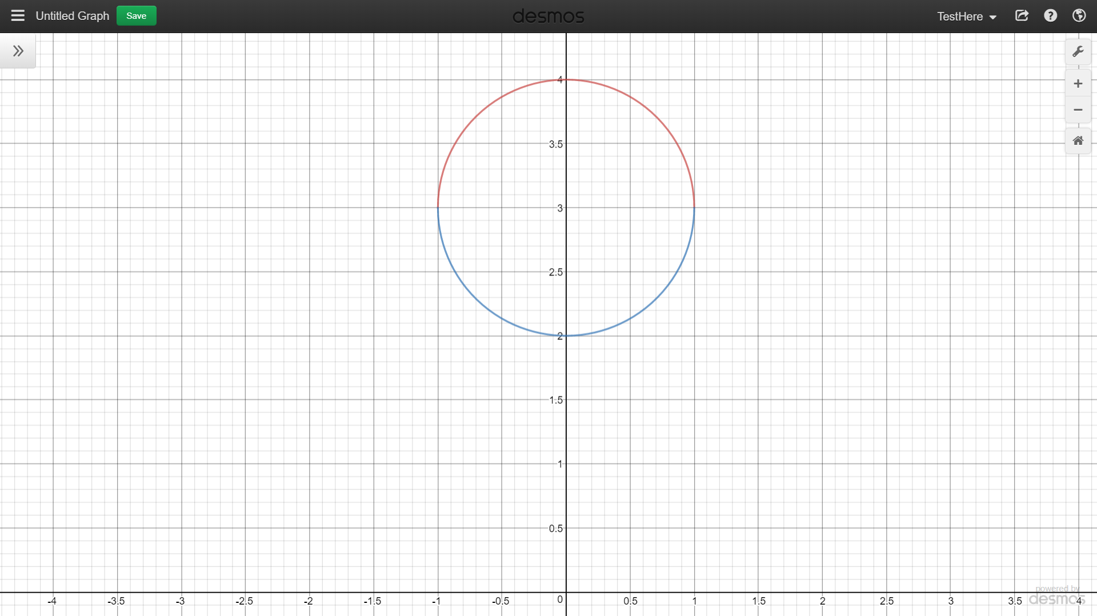The torus could be thought of the area of a circle, times a circle (i.e. $πr^{2}⋅2πr$). using the solids of revolution technics that I will show later, this will be shown to indeed be the case by starting with

Which could easily be represented as two equations. This saves us from using multi-variable calculus, since it’s infinitely easier to apply the technic of solids of revolution in single variable calculus.

I’m not sure if I’ve covered everything from class, so I’ll be sometimes interpreting some things from the book.

## Cross section

Give a 3D object, we take cross sections and it could find formula for the cross sections, then

$$vlume= \int_{a}^{b}{A\left(x\right)dx}$$

Note that this we’re not rotating around an axis, for example:

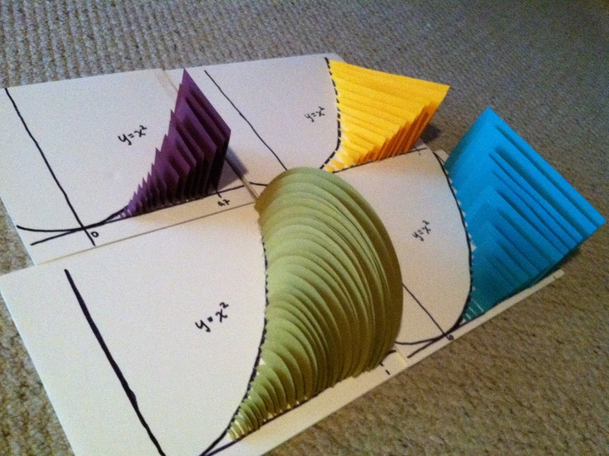

Each of these represent different types of cross section: square, triangle, semi-circle, rectangle. The question will specify what type of cross section you’ll be dealing with

Then keep going from there to solve it

For cross section: basic formulas to remember, just in case:

* Circle area: $πr^{2}$, circle arclength: $2πr$
* Cylinder area: $HERE$, cylinder volume: $πr^{2}h$
* Rectangular pyramid: $\frac{1}{3}\left(width\right)\left(length\right)\left(height\right)$
* Area of Equilateral triangle: this one is a tricky since you need to remember that $\sin\left(\frac{π}{3}\right)=\frac{\sqrt{3}}{2}$. After that, find the base (b), and do

$$\frac{base⋅height}{2}=\frac{l ⋅ \frac{\sqrt{3}}{2}l}{2}=\frac{\sqrt{3}}{4}l^{2}$$

Ex: 3D object bounded by $y=x, y=\sqrt{x}$ and whose cross section perpendicular are square.

The solution is super easy

$$A\left(x\right)={\left(\sqrt{x}-x\right)}^{2}$$

$$V= \int_{0}^{1}{{\left(\sqrt{x}-x\right)}^{2}dx}$$

Find the area of a rectangular pyramid using cross section:

Visual show what this entails. I see that when we’re going up the y axis, the base of the pyramid shrinks . since we’re dealing with a rectangular pyramid, both the width and length chance differently with respect to y, though but should end up at 0 when we reach the maximal height. The width and length should be scaled by their respective amount, which we know to be $w$ and $l$ in our equations.

$$\hat{l}=\left(h-y\right)l$$

Finally, notice that when the height of this equation is zero, we get an extra unwanted $h$, so we divide by h

$$\hat{l}=\frac{\left(h-y\right)l}{h}$$

We do the same for the width, and multiply them together:

$$A=\hat{l}\hat{w}=\frac{{\left(h-y\right)}^{2}lw}{h^{2}}$$

From here, we integrate this formula

$$V=\int_{0}^{h}{\frac{{\left(h-y\right)}^{2}lw}{h^{2}}=…=\frac{1}{3}lwh}$$

Find the area were the base is an eclipse with the are $4x^{2}+9y^{2}=6^{2}$, and having square cross-sections perpendicular to the x=axis. Determine the volume of the object.

We know we’re dealing with squares, we know the bottom area of the square (which is bounded by the top and bottom of the ellipse), and we could find the end points of the ellipse, being $±3$.By rearranging the formula for the ellipse, we get

$$y=\sqrt{4-\frac{4x^{2}}{9}}$$

And one need to double it to consider the bottom half of the ellipse.then squaring it will get you the area of the square

$$A={\left(2\sqrt{4-\frac{4x^{2}}{9}}\right)}^{2}$$

Integrating it from $±3$ will get you the area we’re looking for

$$A=\int_{-3}^{3}{{\left(2\sqrt{4-\frac{4x^{2}}{9}}\right)}^{2}dx}=…=64$$

Consider the solid object whose base is prescribed by the region bounded by the curves $y^{2}=x, y=x^{2}$. If the cross sections perpendicular to the x-axis are equilateral triangles, determine the volume of the solid.

Solution: We know the formula for an equilateral triangle is

$$\frac{\left(base\right)\left(height\right)}{2}$$

And that the base will be calculated by $b= \sqrt{x}-x^{2}$, and for the height, you need to know some trig, namely that since we’re dealing with an equilateral triangle, $θ=\frac{π}{3}$, and $\sin\left(θ\right)=\frac{\sqrt{3}}{2}$

$$b=\sqrt{x}-x^{2}$$

$$h=\frac{\sqrt{3}}{2}b$$

$$a=\frac{bh}{2}=\frac{\frac{\sqrt{3}}{2}bb}{2}=\frac{\sqrt{3}}{4}b^{2}$$

The area between the square root of x and x^2 is one, so

$$\int_{0}^{1}{\frac{\sqrt{3}}{4}{\left(\sqrt{x}-x^{2}\right)}^{2}dx}=…=\frac{9\sqrt{3}}{280}$$

## Solids of revolution

In the previous section, we varied the height as we saw fit, and used shapes as cross sections. In this section, the shape will always be a circle and the height will be determined by our function. A visual example is:

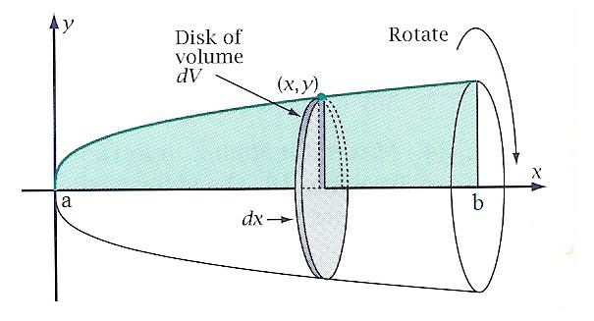

This should make the formula quite intuitive to grasp and derivate on the spot. Since we’re dealing with circle were the radius is variant, we’ll get

$$circle=πr^{2}=πf{\left(x\right)}^{2}$$

And to integrate many such circle over an area:

$$\int_{a}^{b}{πf{\left(x\right)}^{2}dx}$$

There’s a proof in the text book for this, but I’ll leave it out of this study sheet for now. Note that sometimes it could be easier to integrate around the y-axis, and other times you’ll be asked to integrate around a line like $y=3, or x=5$. Examples of this will be bellow

Example: Let $f(x)=x^{2}-2x+2$ wit domain $\left[0,3\right]$ and revolve the area under the graph of $f$ about the x-axis. Determine the corresponding volume of the solid of revolution.

Solution: this is simply a matter of plugging numbers in:

$$π\int_{0}^{3}{{\left(x^{2}-2x+2\right)}^{2}dx}=…=\frac{78π}{5}$$

Example: consider the area between the curve $y=\sqrt{x}$ and the $0≤x≤1$. If this area is revolved around the y-axis, determine the volume of the corresponding solid of revolution.

Solution: In these cases, one must be wary whether you’re intergrating the area between the function and the x-axis or the function and the y axis. Since the question stated that it’s the are we get revolving around the y-axis, it is implicit in MAT137 that it’s the area bounded between the function and the y-axis. For this we need to change our given formula:

$$y=\sqrt{x}→x=y^{2}$$

From here, it’s again a simple matter of plugging umbers in

$$π\int_{0}^{1}{y^{2}dy}=\frac{π}{3}$$

Example: Consider the curve $y=sin⁡(x)$ for $x∈[0,2π]$, rotated about the line $y=1$. Determine the volume of the solid of revolution.

Solution: first, get to know what it means to rotate around $y=1$. This visual should make it clear:

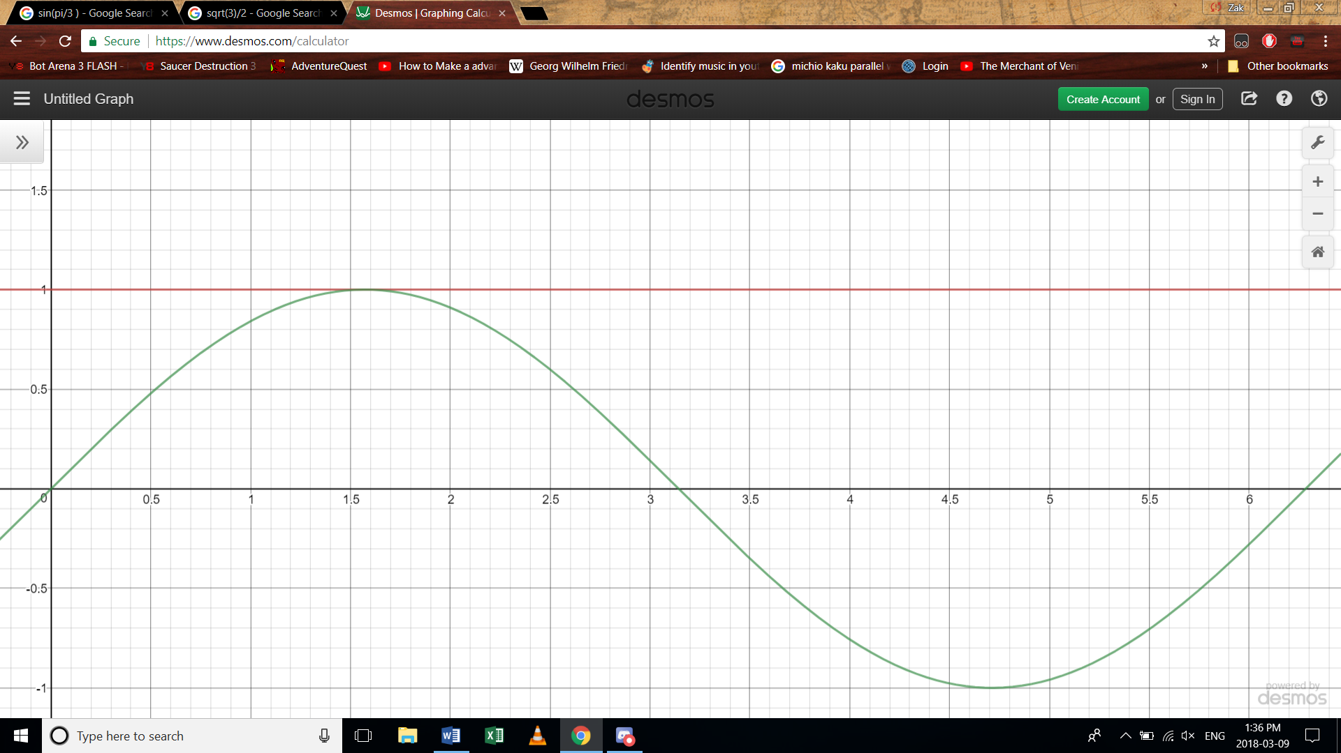

Now since we’re rotating around $y=1,$ and $y=sin⁡(x)$,

$$y-1=\sin\left(x\right)-1$$

$1-sin⁡(x)$ or $\sin\left(x\right)-1$. Notice that if we choose the second one, we’d get negative area at the beginning, which is not what would happen if we rotated this function around $y=1$, therefore it’s the first one. From here, it’s a simple matter of integrate

$$\int_{0}^{2π}{{\left(1-\sin\left(x\right)\right)}^{2}dx}=…=3π^{2}$$

TWO MORE EXAMPLES FROM THE BOOK COULD BE GOOD ESPECIALLY ABOUT THE DIFF. BETWEEN TWO AREAS

## Shells Method

Sometimes, cross-sections/solids of revolution are hard to integrate, like

$$π\int_{0}^{1}{{\arctan\left(x\right)}^{2}dx}$$

And you could be scratching your head hours to figure it out. This is because squaring the arctan makes life very difficult. When you reach something like this and you’re not sure how to proceed, consider shells method. The intuition behind it is as follows: instead of taking slices of a graph and adding them together, takes successive infinitesimally small cylinder, where the middle has been cut out, and add them together. The following image is a exaggeration to show case the idea

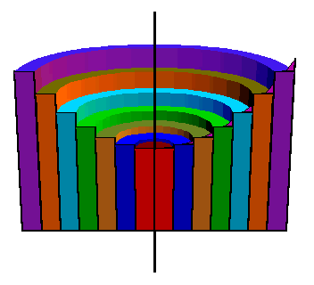

As you could see, we’re adding “shells” together. The formula for this is as follows: Since we’re dealing with circles, we’re going to multiply the final result by $2π$. The distance between the center and the “shell” is $x$, and the height of the “shell” is $f(x)$. All combined together creates the area of one “shell”:

$$area of shell=2πxf\left(x\right)$$

TAKE PICTURE FROM BOOK AND PUT IT HERE

If we’re rotating about the x-axis, then our formula will become

$$2πyf(y)$$

Integrating this volume will yield us the volume. Notice that we’re no longer dealing with $f{\left(x\right)}^{2}$, which is in some cases is a massive improvement. Take our previous example. Applying shells method will tell you that

$$V=\int_{0}^{1}{2πx\arctan\left(x\right)dx}$$

Which is easily integrable using integration by parts and trigonometric substitutions. In the following examples, we’ll cover the basic and give ourselves some hard example to know how to work through

Example: Determine the volume of the object created by rotating the area under the function $f\left(x\right)=\sqrt{x}$ on $[0,4]$.

Solution: this is the simplest example you could have, since it could be solved using both solids of revolution and shells method, and in both cases it a matter of understanding what $\sqrt{x}$ looks like and then plugging in the number

$$2π\int_{0}^{4}{x\sqrt{x}}dx=…=\frac{128π}{5}$$

Example: determine the volume of a sphere with radius r:

Solution: this is easy using cross sections and shell. For the shell method, notice that $f\left(x\right)=\sqrt{r^{2}-x^{2}}.$ This will only take into account the top part of the sphere, so we’ll multiply it by 2

Therefore:

$$4π\int_{-r}^{r}{x\sqrt{r^{2}-x^{2}}dx}=-π\int_{r^{2}}^{0}{\sqrt{u}du}=…=\frac{4}{3}πr^{2}$$

Example: consider the curve $y=arcsin⁡(x)$ for $x∈[0,1]$. If the area between the curve and the y-axis is rotated about the x-axis, determine the volume of the corresponding object

Solution: notice we’re rotating about the x-axis. We need to convert our formula so that y is dependent on x.

$$y=\arcsin\left(x\right)→x=\sin\left(y\right)$$

We also need to convert the bounds for the formula, so $\arcsin\left(0\right)=0,\arcsin\left(1\right)=\frac{π}{2}$

$$2π\int_{0}^{\frac{π}{2}}{ysin\left(y\right)dy}=int by parts=2π$$

Example: consider the area under the curve $y=e^{x^{2}}$ on $\left[0,2\right]$, which is rotated abouteh y-axis. Determine the volume of the corresponding solid of revolution.

Solution: this would be extremely hard to integrate using the cross-section method, simply because

$$π∫{\left(e^{x^{2}}\right)}^{2}dx$$

Is hard to integrate. This is a great example were Shells method is useful, since that extra x infront makes a world of difference: $$2π\int_{0}^{4}{xe^{x^{2}}dx}=u sub=π\left(e^{4}-1\right)$$

Example: determine the volume of the object given by rotating the area enclosed between $y=\sqrt{x}$ and $y=x^{2}$ about the y-axis

Solution: like last time, we’ve gotten two functions and must find the area of the difference in volume. For solids of revolution, we’ve gotten the difference of both function squared, for shell integration, it is very similar, and I’ll assume the formula is intuitive enough:

$$\int_{0}^{1}{2πx\left(\sqrt{x}-x^{2}\right)dx=…=\frac{2π}{15}}$$

Example: Determine the volume of the object given by rotating the area enclosed by $y=\sqrt{x}$ and $y=x^{2}$ about $x=1$.

Solution: this is daunting at first, but notice we’re simply shifting our x.

IMAGE FOM BOOK HERE

The solution comes from realising that in this scenario, our x value must now start at 1, since that is were the beginning of the function is, and the x value must be zero at the end so that our function end correctly, so to start at one and end at 0 we need

$$V=\int_{0}^{1}{2π\left(1-x\right)\left(\sqrt{x}-x^{2}\right)=…=\frac{π}{5}}$$